API automation using TestNG

Scenario :

1. Use post method and login to API URL
2. Capture the status code and repones body

Project folder structure

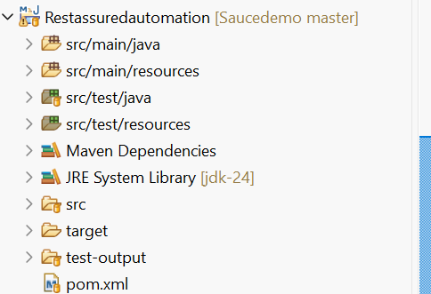

Dependency added to POM xml file

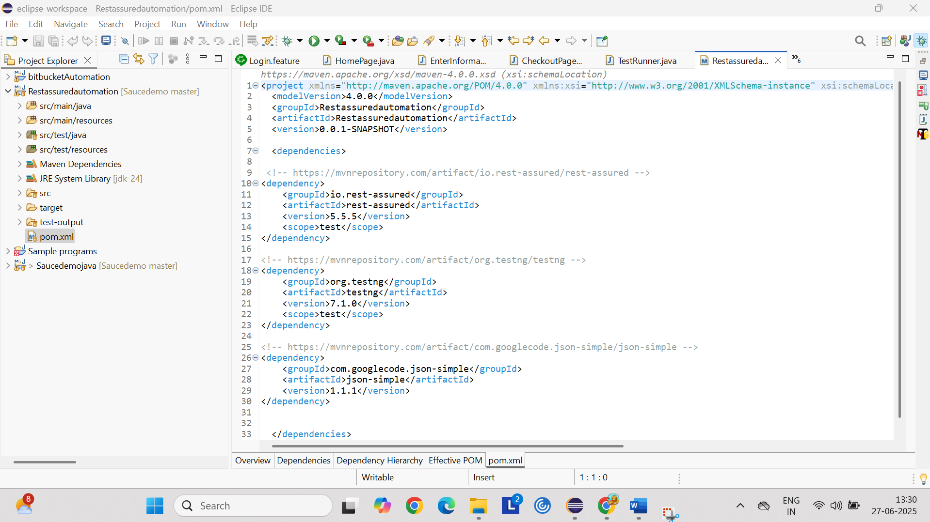

Test class where the project is written and executed with 2 methods

1. Positive
2. Negative

API URL use: <https://reqres.in/api/login>

Positive scenario request payload

{ "email": "eve.holt@reqres.in", "password": "cityslicka"}

Negative scenario request payload

{ "email": "test@gmail.com", "password": "test"}

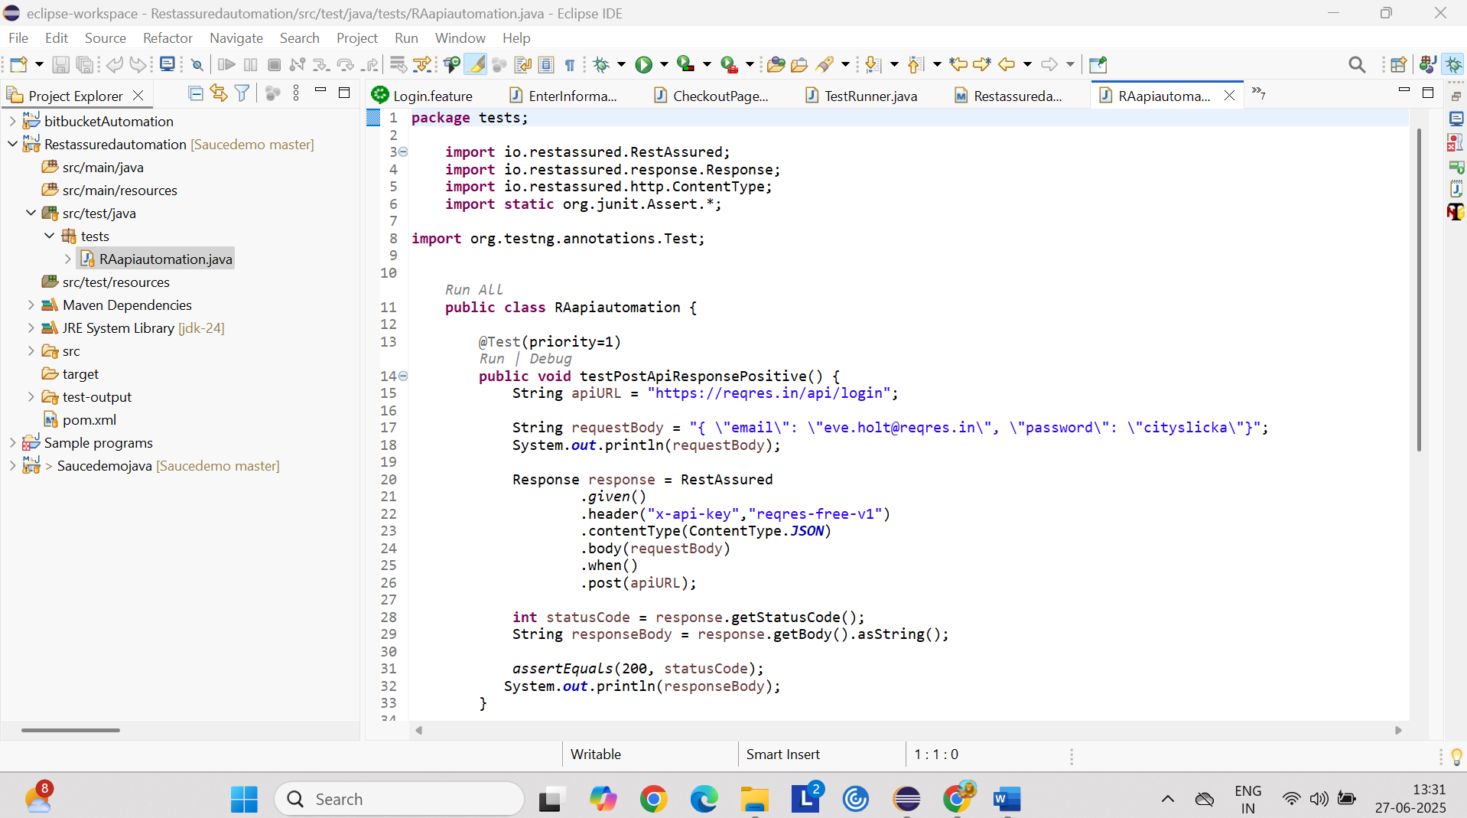

Recording

